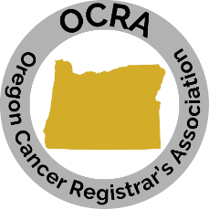

OCRA Membership Application for 2023

(Check and cash only)
To pay by CC register online: http://www.ocra-oregon.org/membership/

If you are a new member, once you have your user name/pw for OCRA you will need to update your profile with your information. If you are an existing member, it is your responsibility to make changes to your profile. http://www.ocra-oregon.org/

NAME:________________________________________ CREDENTIALS: ____________________

EMPLOYER:___________________________________ POSITION:________________________

PREFERRED EMAIL: ________________________________

PREFERRED PHONE: _________________________________

Membership Classifications:

Active Member: Certified Cancer Registrars or persons whose primary occupation is involved with any or all facets of cancer registry work. (i.e., abstractors, follow-up staff, contractors)

Student Membership: Shall be persons who do not meet the requirements for an Active membership and are enrolled in an allied health care curriculum. A Student Member shall be eligible for this classification of membership for no more than one consecutive two-year period. A Student Member shall be entitled to serve on committees but shall not vote, hold office or chair a committee.

I am applying for: _______ Active Membership - $45.00 per year
_______ Student Membership – no charge **MUST register via paper & send to Treasurer
School name/Program: __________________________________________________

Dues shall be due on November 1st. Membership will be declared forfeited after the 15th day in December. A former member whose membership had been forfeited for nonpayment of dues must submit a new application for membership with annual dues. If denied membership, the dues shall be refunded. Any new (1st time) member joining prior to the workshop will pay the full membership fee and be retroactively instated as a member and able to register as an OCRA member for the workshop.

____________________________________________ _____________________________
SIGNATURE OF APPLICANT DATE
All fields are required & signature to process application.
Send application and payment to OCRA Treasurer
Rebecca Berwager
1105 NE 131st Circle Vancouver, WA 98685

